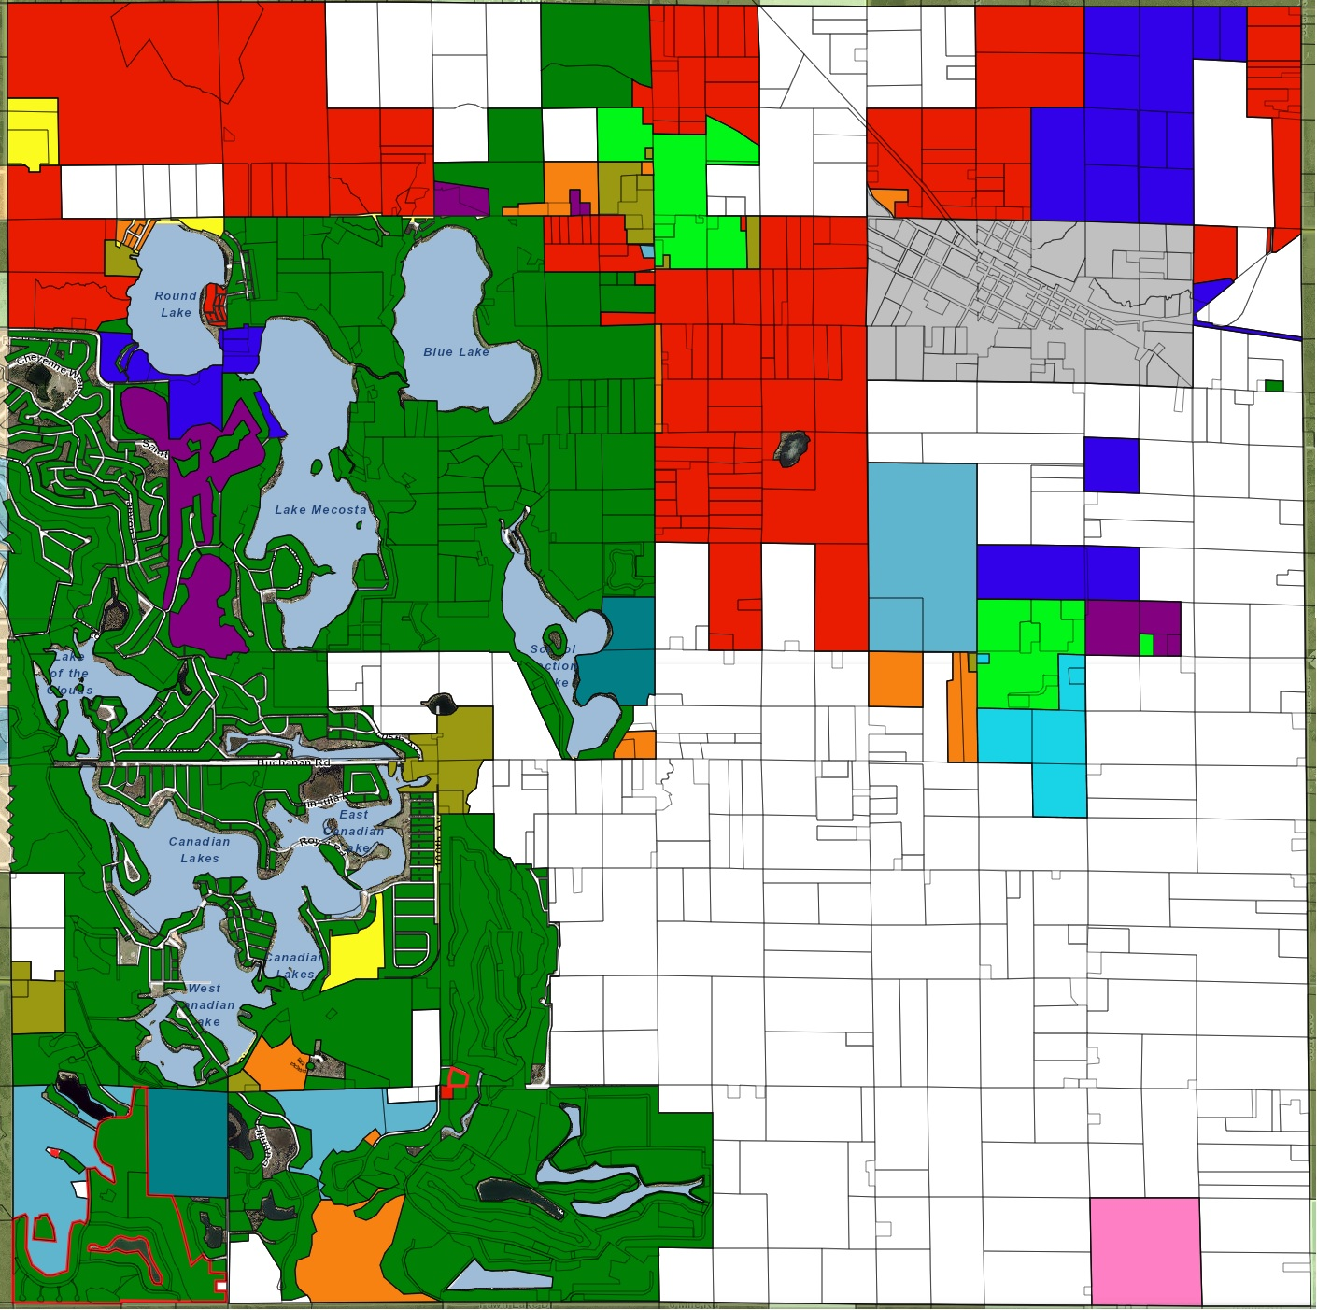

Updated Aug 24, 2023

**Morton Township**

**Sectional Zoning**